Automatic representation of visual possibility
What is the nature of the experience of a potential whole when only parts are presented?
7 experiments (inspired by Tetris). Results: participants confused more often parts with whole when parts could be combined into this whole. Discussion: potential states of the world could take the form of automatic representations.
More precisely: we know representations of potential states of the world occur in higher level thinking but this exp suggests that they can also occur automatically, as perceptions.

EXPERIMENTS: “respond, under time pressure, to a particular target appearing within a stream of distractors. Sometimes, the distractors were object pairs that could create the subject’s target in combination; otherwise, the distractors could not create the subject’s target but shared other low-level properties.”

EXP1: can subjects (300) confuse possible objects for real ones?
Stimuli: Stimuli consisted of custom-designed “Tetris” pieces appearing either in pairs or alone
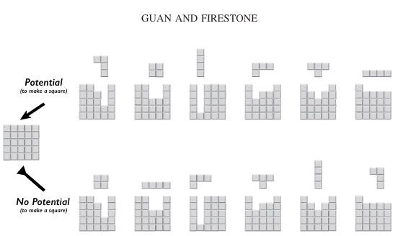

- Distractors that are potentially the target

- Distractors that aren’t . potentially the target
Those 19 images are the stimulus set: one target the subject must identify rapidly (by pressing spacebar) amongst 18 distractors presented sequentially.
Image (600ms) Blank (1,2s) Image (600ms) Blank (1,2s) etc…
84 trials total: 24 target, 24 trials with 4 potential target distractors, 24 trials with 4 distractors having no potential and 12 trials with 2 bottom-only distractors.
Trial order is randomized between participants with condition that half of target trials are directly preceded by a potential trial and the other half by a no potential trial (including bottom-only?).
Feedback: border of the screen flashes green/red for 200ms
Filtering: participants with <75% good answers and with incomplete data are eliminated.
Data we’re interested into:
- is z(FA) higher for potential targets than for pure distractors?
- is response time different for targets occurring after a potential target/pure distractor (in correct answers only)?
- is z(FA) different at the end than the beginning of the study?

IMPORTANT: single blind study – do not mention “possibility” in the instructions. We can pass the test online at link: http:// perceptionresearch.org/tetris

EXP2:

